Session 1: Why Identity Matters

Defining Terms
Identity:
"the fact of being who or what a person or thing is" (Oxford)
"the qualities, beliefs, personality traits, appearance, and/or expressions that characterize a person" (Wikipedia)

- Cultural messages

- Humans Design: Humans long for
  - _____________
  - _______________
  - ___________________

- Developing a Sense of Identity
  - Social Influences
    - In today’s culture, the focus has become all about _________________ and the management of the ______________ of others.
    - For young people this has been exacerbated by ________________ from
      - ____________________,
      - _______________________________,
      - ____________________________________.
  - The truth of our identity will be apparent when we are in ____________________ to the ______________________________.

- The Correct Identity in Christ is always connected to _________________ and _____________________________

Because He Is | I am | Scriptural truth
The Creator | His Masterpiece  An Image Bearer of God  Made right with purpose  Made for all my days | Psalm 139  Ephesians 2:8-10  Romans 9:20-21
Holy | Unworthy  Guilty  All have sinned  Not a comparison to others  Pretending we are perfect creates turmoil | Romans 3:23  Ephesians 2:1  Isaiah 64:6
LOVE | Forgiven  Redeemed  Recreated  No condemnation | Colossians 1:21-22  Romans 5:8-9  Romans 8:1
Abba, Father | His child  Joint Heir  Welcomed to His Throne  Embraced  Disciplined | Psalm 103:13  Hebrews 4:15-16  Hebrews 12:4-12
Gracious | Accepted  Nothing good I do can make Him love me more, nothing bad I do can make Him love me less. | Romans 8:31-39
A Healer who Redeems | My Pain Is Repurposed  Beauty for Ashes  Broken and Beautiful | II Corinthians 1:8-9, Romans 8:28-30  Isaiah

- The Plan
  - ________________________
  - ______________________________________________
  - _____________________________________
  - _______________________________________________
Session 2 : A Biblical Sexual Ethic

- Approaches to talking about sexuality
  - _____________________
  - Read/watch this resource then we can talk
  - Don’t Do It (____________________)
  - Give information ________________
  - _________________________ about a gift worth protecting
- A Responsibility for Teaching a Sexual Ethic
  - Parents have the responsibility before God to be the _____________________ of their children in areas of faith and morality.
  - Children need ______________________ in their lives who will say the same things their parents say.
  - ________ is nearly impossible; a lack of information does not equal __________.
  - Because of these issues, Christian ministries must collaborate with parents, be ___________ in execution, but _____________ in truth.
- Scriptural Truths
  - Sex was designed for the context of a marriage relationship between a husband and wife
    - Genesis 2:24
    - 1 Corinthians 6
    - Romans 1
  - Sex the way God intended, is an _____________________
    - Proverbs 5:18-19
    - 1 Corinthians 7:3-5
  - Sex should be ________________ and _______________________
    - Hebrews 13:4
  - Sexual Temptation is ____________________
    - Song of Solomon
  - We are to __________________ sexual temptation
    - 1 Corinthians 6:18-20
- Reasons why Biblical boundaries are violated
  - Young men are flooded with ______________ that drive interest
  - Young women may think sex indicates they are _________ & ___________
  - Insecure youth think sexual behaviors ____________ and _____________ the relationship
  - Teens may see sex as a sign of maturity, normal, or inescapable because of _____________
  - Lack of ____________ about biblical lines (“but this doesn’t count as sex”)
  - Sometimes it is just __________________
- Practical Teaching Steps
  - Avoid _________________________
    - _______________ is not bliss, _______________ is. Scripture teaches on the topic, so we should never avoid it. Create an environment where kids can ask hard questions and expect that you will be able to respond to them without fear or judgment.
  - Avoid ______________________ on Boundaries
    - Boundaries can be helpful in the moment, but they are not solutions. Do not simply help young people define lines for thoughts and behaviors. Instead, help them to think and behave righteously.
  - Emphasize ______________________
    - Do not spend the majority of time arguing from science and studies about the need for a Biblical sexual ethic. We do not live rightly because it is good, but because it is Godly. Scripture comes first, everything else is secondary.
  - Emphasize __________________
    - Sanctification is the goal for all humanity, whether married or not (1 Thess 4:3). Help young people and couples think differently about their current context and how they can glorify God with their bodies and the relationship status.
  - Be _________________ about Difficult Topics
    - Develop a consistent response to difficult topics (like LGBTQ issues) that allow for clear and consistent communication of biblical teaching, focusing on purpose and holiness, not just boundaries.

Session 3: Social Contagion

- Sociological shifts
  - _______________________ and ______________________________:
    - Across borders
    - In real time
  - Information Sharing and Consumption:
    - Primary source of ___________
    - Viral spread of information
  - ______________________________:
    - Role in creating awareness and mobilization
  - Personal______________________:
    - New opportunities for self-expression and entrepreneurship.
  - Cultural Impact:
    - Creates shifts in popular culture, trends, and normalization
    - Memes, challenges, and viral content can quickly become mainstream
- How much time?
  - ________ hours a day (Gallup, 2023)
    - ______________ slightly more
    - _______________adolescents higher
  - Add _______ hours a day for ____________ (AACAP, 2024)
- Effects on Impulse Control
  - Related to less self-control in __________________
  - Related to ___________________
  - Oversharing
  - FOMO
  - Decreased attention span

- Effects on Emotion
  - Damages ____________________—produces negative emotions
  - Increases in Loneliness, Frustration and Anger
  - Increased Depression, Anxiety,
  - Impaired brain functioning
  - Posting selfies _____________ Mood
- Body Image
  - Social Media usage increases desire for _____________ and active eating disorders
  - Decreases Body satisfaction and sense of ___________________
  - Increases desire for __________________________
- Hyperconnectivity
  - Individuals have a difficult time being alone
  - __________________________ is limited
  - Empty time immediately channeled into media instead of observations/interactions with newness—leads to limited exposures and the ________________________ of experience.
  - Perceived intimacy without meaningfulness and depth
  - Interactions tend to be abbreviated and without the courtesies usually associated with interactions:
    - Small talk
    - Expressed interest in the welfare of others---all about self
    - Eye-contact, non-verbals
    - Proper grammar and spelling
- Effects on Individuality
  - Reduces potential to think independently (Huberman, 2011)
  - ___________________ and ________________________
    - Algorithms prioritize content that aligns with users' existing beliefs and interests, creating a filter bubble where users are more likely to encounter information that reinforces their pre-existing views.
    - Echo chamber based on past engagement
  - _____________________________________
  - Perceived Social ________________________
- Influencers are not _________________
  - Random strangers steer perspectives and behaviors, creating norms, being perceived as experts, and affecting worldview with no consideration whether they are credible (much less godly) sources.

Homework: Watch The Social Dilemma on Netflix

Session 4: Moderating the Mental Health Movement: Emotional Tyranny

- Some Common Viewpoints
  - “Christians should never feel negative emotions—if you do, just stop it.”
  - “Christians should always be happy.—See that woman over there, I see her crying a lot. She must not be having her devotions.”
  - “I can’t help it, it is just the way I feel.”
  - “If I do something I don’t feel like doing, that is hypocrisy and God hates hypocrites.”

- Theological Principles
  - The Ability to experience emotion is a _____________________________ of God
    - Anger
    - Grief
    - Compassion
    - Joy
    - Jealousy
  - As Communicable Attributes From God, Emotions Are _____________________.
    - God experiences emotion in _____________________.
    - Our experience has the potential to be _______________ and guided by our ________________________.
  - Most often in Scripture, God does not separate emotions from the ____________ behind them
    - Cast all your anxieties upon Him --_______________________________.
    - Rejoice, and be exceeding glad---_________________________________ _____________________
    - Do not be discouraged—_______________________________________ ______________________________________________

- Car Diagram
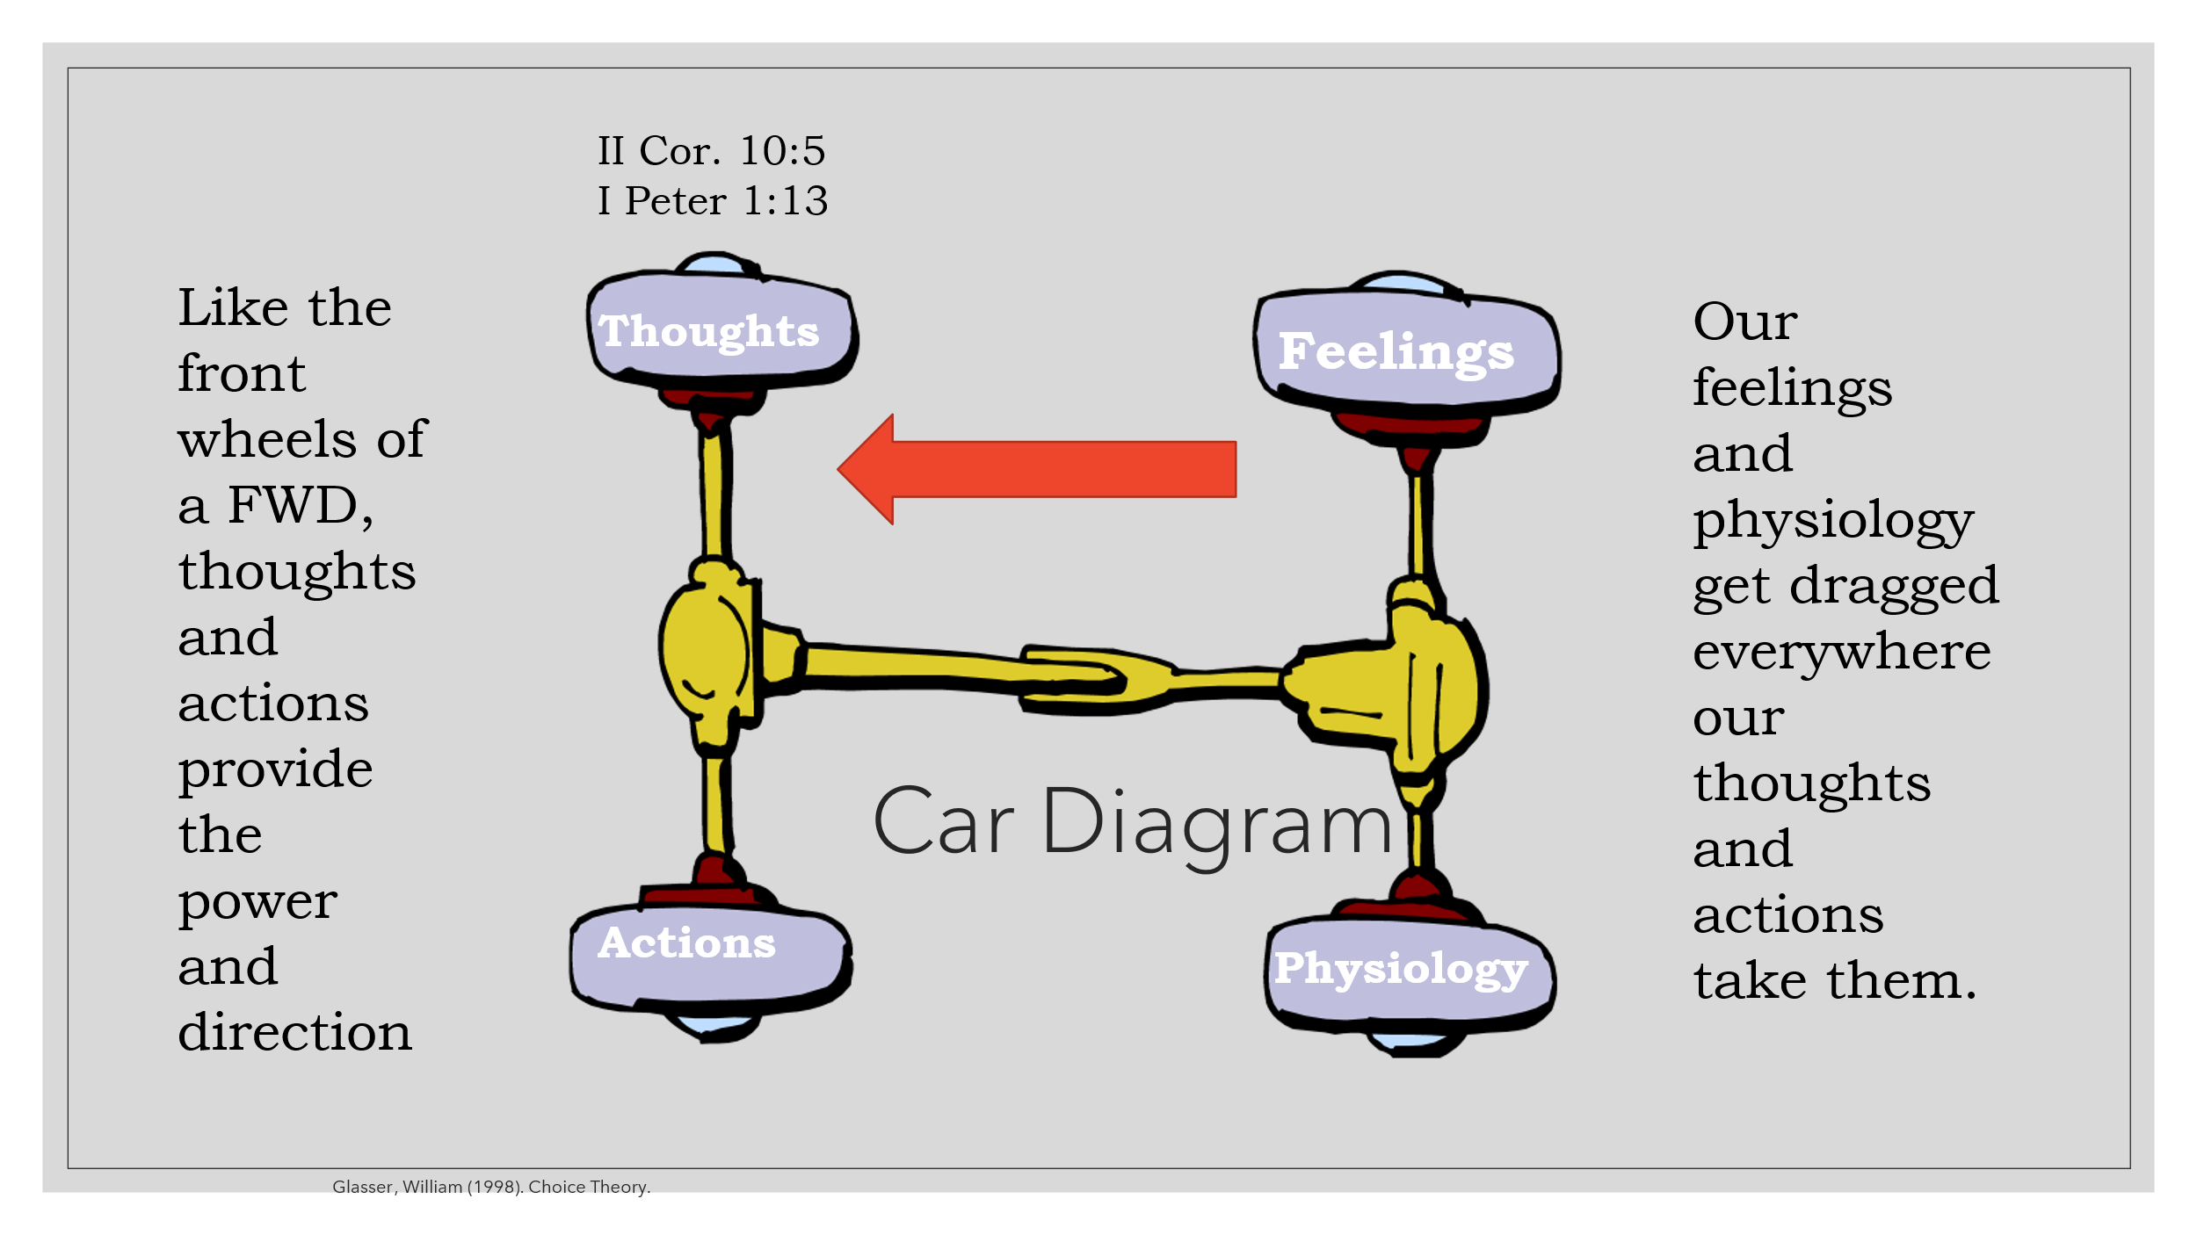
  - Our thoughts are a collection of our theological beliefs, values and habitual ways of viewing life. Some of these habits of thinking can be absorbed from our culture/environment. All of these are activated/ruled by our spiritual heart condition.
  - Illustrating Passages:
    - Elijah (I Kings 19)
      - Elijah gets to a state of depression/fear because he was
        - thinking about Jezebel’s threats and not God’s victory and
        - tired and hungry
      - God intervenes
        - Met physical needs
        - Delivered Truth
        - Gave Elijah job and companion
    - Jeremiah (Lamentations 3)
      - Jeremiah witnessed destruction of Jerusalem and faced Physical, Social, Emotional and Spiritual hardship. Result: Severe _________________
      - Remediation
        - Specific ________________
        - Theologically accurate ___________________
    - Joy in Trouble (Philippians 4:4-9) Don’t be anxious—How?
      - Pray/Petition
      - With THANKSGIVING
      - Think on right things
      - Do what Paul taught and did
    - Love (I Corinthians 13) What is love?
      - _____________(kind, does not boast, is not rude)
      - _______________ (patient, does not envy, is not proud, is not self-seeking, is not easily angered, keeps no record of wrongs, does not delight in evil, rejoices with the truth, etc)

- Cognitive Restructuring (Romans 12:1-2, Renewing the Mind)
  - Focus on Truth
    - Listen to music that focuses on the Lord
    - Read your Bible
    - Memorize Scripture
    - Make lists of gratitude

  - Smart Behaviors
    - Daily Attentions (Sing, smell flowers, be still, read the Word)
    - Limit Social Media time
    - Eat right, exercise, use your brain, sleep, play
    - Weighted blanket
    - Breathing apps on phone
    - Limit caffeine
    - Set reasonable goals
    - Pray, Go to church
    - Surrender your day to God
    - Get counsel from an adult, parent, teacher, youth pastor/leader

- Concluding thoughts
  - If we have a biblical perspective (Colossians 3) and engage in God-honoring behaviors, we will have congruent, God-honoring feelings. This might not always be happiness. The world desires happiness because it is comfortable. Discomfort drives us towards God.

  - Our emotions could be a transient state that we process through as we reconcile our experiences with our theological beliefs.
  - If physiological affects are ruled out, long-term emotional difficulty may sometimes serve as a barometer, indicating that correction is needed in theological beliefs, habitual thinking patterns or in action

James & Lynelle Buchanan have been married for over 31 years, most of them happily. Until recently, both James and Lynelle worked at Clarks Summit University. James served as the Dean of the School of Bible & Theology at Clarks Summit University and as a pastor for over 20 years at Berean Church in Scranton. Currently James is serving as the senior pastor at Neath Church in Warren Center, PA. Lynelle served as the Dean of the School of Behavioral Sciences at Clarks Summit University where she taught full-time for over 20 years. She now administers the online Masters of Counseling program at Cairn University. Together they have 3 children. Their oldest son is serving as the music director at Willo-Hill Baptist Church in Ohio, while their younger son and daughter are studying at Cairn University. As a family they enjoy spending time together, playing games, and traveling.
Contact Info:
James Buchanan—jimmyb981@comcast.net
Lynelle Buchanan—lynellejbuchanan@gmail.com

